**1. Split this string**

**Basic Python**

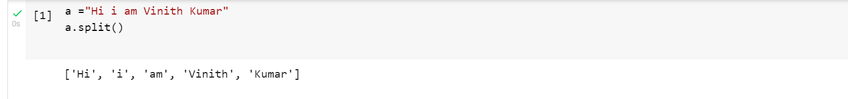

**2. Use .format() to print the following string.**

**Output should be: The diameter of Earth is 12742 kilometers.**

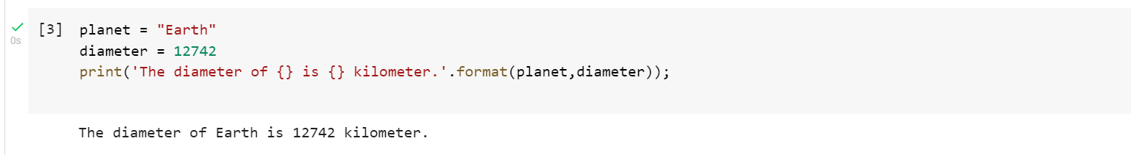

**3. In this nest dictionary grab the word "hello"**

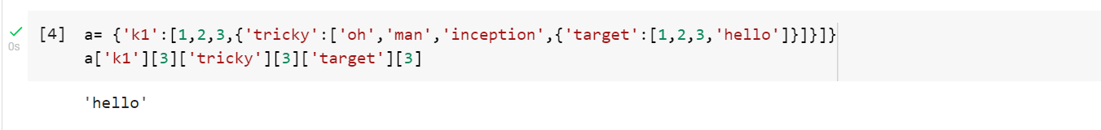

**NUMPY**

**4.1 Create an array of 10 zeros?**

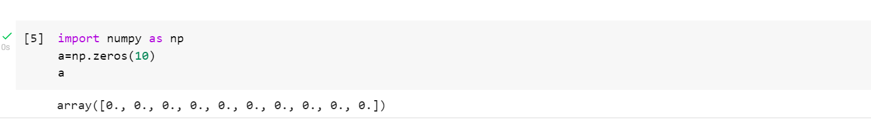

**4.2 Create an array of 10 fives?**

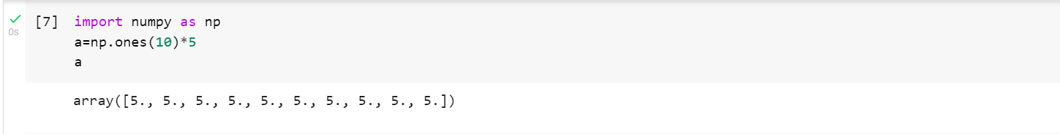

**5. Create an array of all the even integers from 20 to 35**

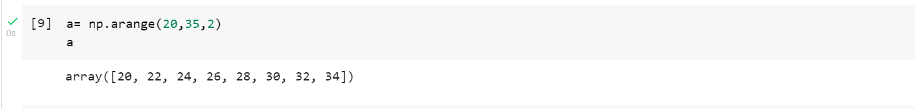

**6. Create a 3x3 matrix with values ranging from 0 to 8**

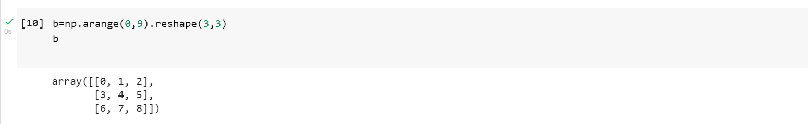

**7. Concatenate a and b**

**a = np.array([1, 2, 3]), b = np.array([4, 5, 6])**

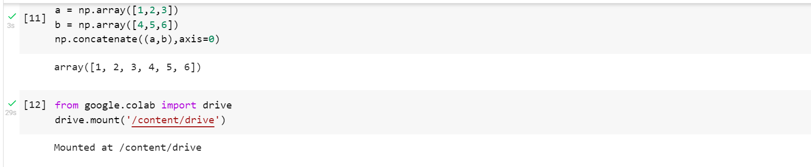

**Pandas**

**8. Create a dataframe with 3 rows and 2 columns**

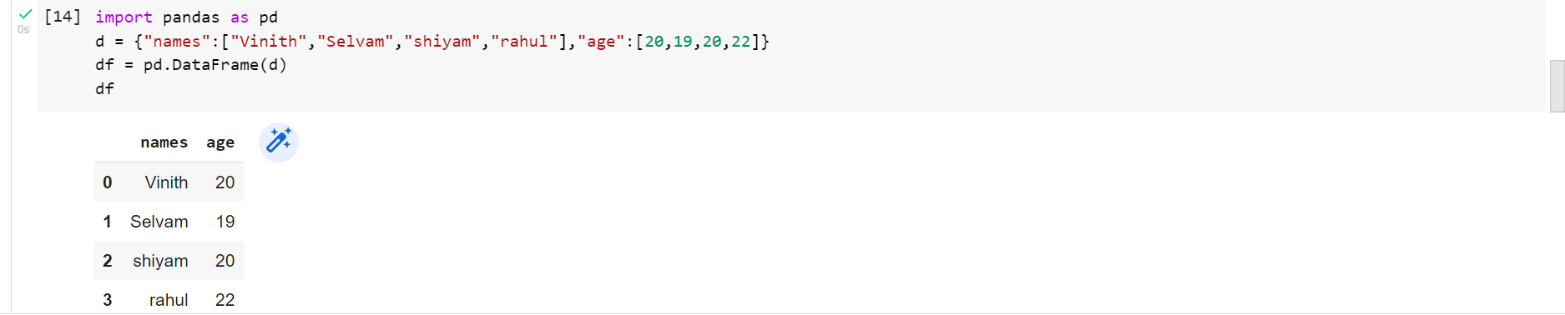

**9. Generate the series of dates from 1st Jan, 2023 to 10th Feb, 2023**



2023-01-01 00:00:00

2023-01-02 00:00:00

2023-01-03 00:00:00

2023-01-04 00:00:00

2023-01-05 00:00:00

2023-01-06 00:00:00

2023-01-07 00:00:00

2023-01-08 00:00:00

2023-01-09 00:00:00

2023-01-10 00:00:00

2023-01-11 00:00:00

2023-01-12 00:00:00

2023-01-13 00:00:00

2023-01-14 00:00:00

2023-01-15 00:00:00

2023-01-16 00:00:00

2023-01-17 00:00:00

2023-01-18 00:00:00

2023-01-19 00:00:00

2023-01-20 00:00:00

2023-01-21 00:00:00

2023-01-22 00:00:00

2023-01-23 00:00:00

2023-01-24 00:00:00

2023-01-25 00:00:00

2023-01-26 00:00:00

2023-01-27 00:00:00

2023-01-28 00:00:00

2023-01-29 00:00:00

2023-01-30 00:00:00

2023-01-31 00:00:00

2023-02-01 00:00:00

2023-02-02 00:00:00

2023-02-03 00:00:00

2023-02-04 00:00:00

2023-02-05 00:00:00

2023-02-06 00:00:00

2023-02-07 00:00:00

2023-02-08 00:00:00

2023-02-09 00:00:00

2023-02-10 00:00:00

2023-02-11 00:00:00

2023-02-12 00:00:00

2023-02-13 00:00:00

2023-02-14 00:00:00

2023-02-15 00:00:00

2023-02-16 00:00:00

2023-02-17 00:00:00

2023-02-18 00:00:00

2023-02-19 00:00:00

2023-02-20 00:00:00

2023-02-21 00:00:00

2023-02-22 00:00:00

2023-02-23 00:00:00

2023-02-24 00:00:00

2023-02-25 00:00:00

2023-02-26 00:00:00

2023-02-27 00:00:00

2023-02-28 00:00:00

2023-03-01 00:00:00

2023-03-02 00:00:00

2023-03-03 00:00:00

2023-03-04 00:00:00

2023-03-05 00:00:00

2023-03-06 00:00:00

2023-03-07 00:00:00

2023-03-08 00:00:00

2023-03-09 00:00:00

2023-03-10 00:00:00

2023-03-11 00:00:00

2023-03-12 00:00:00

2023-03-13 00:00:00

2023-03-14 00:00:00

2023-03-15 00:00:00

2023-03-16 00:00:00

2023-03-17 00:00:00

2023-03-18 00:00:00

2023-03-19 00:00:00

2023-03-20 00:00:00

2023-03-21 00:00:00

2023-03-22 00:00:00

2023-03-23 00:00:00

2023-03-24 00:00:00

2023-03-25 00:00:00

2023-03-26 00:00:00

2023-03-27 00:00:00

2023-03-28 00:00:00

2023-03-29 00:00:00

2023-03-30 00:00:00

2023-03-31 00:00:00

2023-04-01 00:00:00

2023-04-02 00:00:00

2023-04-03 00:00:00

2023-04-04 00:00:00

2023-04-05 00:00:00

2023-04-06 00:00:00

2023-04-07 00:00:00

2023-04-08 00:00:00

2023-04-09 00:00:00

2023-04-10 00:00:00

2023-04-11 00:00:00

2023-04-12 00:00:00

2023-04-13 00:00:00

2023-04-14 00:00:00

2023-04-15 00:00:00

2023-04-16 00:00:00

2023-04-17 00:00:00

2023-04-18 00:00:00

2023-04-19 00:00:00

2023-04-20 00:00:00

2023-04-21 00:00:00

2023-04-22 00:00:00

2023-04-23 00:00:00

2023-04-24 00:00:00

2023-04-25 00:00:00

2023-04-26 00:00:00

2023-04-27 00:00:00

2023-04-28 00:00:00

2023-04-29 00:00:00

2023-04-30 00:00:00

2023-05-01 00:00:00

2023-05-02 00:00:00

2023-05-03 00:00:00

2023-05-04 00:00:00

2023-05-05 00:00:00

2023-05-06 00:00:00

2023-05-07 00:00:00

2023-05-08 00:00:00

2023-05-09 00:00:00

2023-05-10 00:00:00

2023-05-11 00:00:00

2023-05-12 00:00:00

2023-05-13 00:00:00

2023-05-14 00:00:00

2023-05-15 00:00:00

2023-05-16 00:00:00

2023-05-17 00:00:00

2023-05-18 00:00:00

2023-05-19 00:00:00

2023-05-20 00:00:00

2023-05-21 00:00:00

2023-05-22 00:00:00

2023-05-23 00:00:00

2023-05-24 00:00:00

2023-05-25 00:00:00

2023-05-26 00:00:00

2023-05-27 00:00:00

2023-05-28 00:00:00

2023-05-29 00:00:00

2023-05-30 00:00:00

2023-05-31 00:00:00

2023-06-01 00:00:00

2023-06-02 00:00:00

2023-06-03 00:00:00

2023-06-04 00:00:00

2023-06-05 00:00:00

2023-06-06 00:00:00

2023-06-07 00:00:00

2023-06-08 00:00:00

2023-06-09 00:00:00

2023-06-10 00:00:00

2023-06-11 00:00:00

2023-06-12 00:00:00

2023-06-13 00:00:00

2023-06-14 00:00:00

2023-06-15 00:00:00

2023-06-16 00:00:00

2023-06-17 00:00:00

2023-06-18 00:00:00

2023-06-19 00:00:00

2023-06-20 00:00:00

2023-06-21 00:00:00

2023-06-22 00:00:00

2023-06-23 00:00:00

2023-06-24 00:00:00

2023-06-25 00:00:00

2023-06-26 00:00:00

2023-06-27 00:00:00

2023-06-28 00:00:00

2023-06-29 00:00:00

2023-06-30 00:00:00

2023-07-01 00:00:00

2023-07-02 00:00:00

2023-07-03 00:00:00

2023-07-04 00:00:00

2023-07-05 00:00:00

2023-07-06 00:00:00

2023-07-07 00:00:00

2023-07-08 00:00:00

2023-07-09 00:00:00

2023-07-10 00:00:00

2023-07-11 00:00:00

2023-07-12 00:00:00

2023-07-13 00:00:00

2023-07-14 00:00:00

2023-07-15 00:00:00

2023-07-16 00:00:00

2023-07-17 00:00:00

2023-07-18 00:00:00

2023-07-19 00:00:00

2023-07-20 00:00:00

2023-07-21 00:00:00

2023-07-22 00:00:00

2023-07-23 00:00:00

2023-07-24 00:00:00

2023-07-25 00:00:00

2023-07-26 00:00:00

2023-07-27 00:00:00

2023-07-28 00:00:00

2023-07-29 00:00:00

2023-07-30 00:00:00

2023-07-31 00:00:00

2023-08-01 00:00:00

2023-08-02 00:00:00

2023-08-03 00:00:00

2023-08-04 00:00:00

2023-08-05 00:00:00

2023-08-06 00:00:00

2023-08-07 00:00:00

2023-08-08 00:00:00

2023-08-09 00:00:00

2023-08-10 00:00:00

2023-08-11 00:00:00

2023-08-12 00:00:00

2023-08-13 00:00:00

2023-08-14 00:00:00

2023-08-15 00:00:00

2023-08-16 00:00:00

2023-08-17 00:00:00

2023-08-18 00:00:00

2023-08-19 00:00:00

2023-08-20 00:00:00

2023-08-21 00:00:00

2023-08-22 00:00:00

2023-08-23 00:00:00

2023-08-24 00:00:00

2023-08-25 00:00:00

2023-08-26 00:00:00

2023-08-27 00:00:00

2023-08-28 00:00:00

2023-08-29 00:00:00

2023-08-30 00:00:00

2023-08-31 00:00:00

2023-09-01 00:00:00

2023-09-02 00:00:00

2023-09-03 00:00:00

2023-09-04 00:00:00

2023-09-05 00:00:00

2023-09-06 00:00:00

2023-09-07 00:00:00

2023-09-08 00:00:00

2023-09-09 00:00:00

2023-09-10 00:00:00

2023-09-11 00:00:00

2023-09-12 00:00:00

2023-09-13 00:00:00

2023-09-14 00:00:00

2023-09-15 00:00:00

2023-09-16 00:00:00

2023-09-17 00:00:00

2023-09-18 00:00:00

2023-09-19 00:00:00

2023-09-20 00:00:00

2023-09-21 00:00:00

2023-09-22 00:00:00

2023-09-23 00:00:00

2023-09-24 00:00:00

2023-09-25 00:00:00

2023-09-26 00:00:00

2023-09-27 00:00:00

2023-09-28 00:00:00

2023-09-29 00:00:00

2023-09-30 00:00:00

2023-10-01 00:00:00

2023-10-02 00:00:00

**10. Create 2D list to DataFrame**

**lists = [[1, 'aaa', 22], [2, 'bbb', 25], [3, 'ccc', 24]]**

